**Name: -Srikanth.K**

**Roll no: -19BCS4522**

**Ex.1 *LED flasher.***

**Circuit Diagram:**

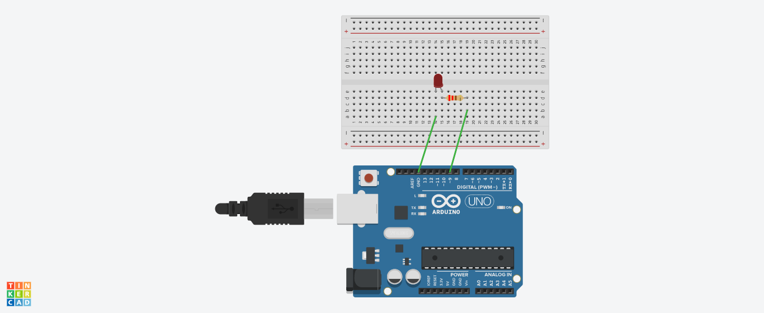

**Theory:**

**Concept Used:**

1)In this experiment I have used the concept of p-n junction diode.

2) To make a circuit on Bread Board.

3) Logic code for Arduino UNO, using Loop statement.

4)How and why resistance is used in a circuit.

**Learning and Observations:**

Learning:

1)I have learnt to use Arduino Board and how code works to make light flash.

2)Arduino board has Digital pins and Analog pins.

Digital pin provides Input as well as Output, but Analog pin provides only input.

3)The Arduino board has ~ sign in Digital pin side which is also known as Pulse Width Modulation(PWM).

These pins help’s in getting analog results with digital means.

4)How a circuit on breadboard is placed so that it can work properly.

5)Digital Pin provides 5V Power supply to the circuit.

6)Since the LED can bear a limited supply of voltage so we have used resistance in series with the LED so that the voltage gets divided and LED can use the require amount of voltage.

**Observations:**

1)If we connect the ‘n’ terminal of the LED to other terminal except ground(GND), hence the circuit will be incomplete and we cannot get the desired output.

2)I connected the ‘p’ terminal of the p-n junction diodes to the Digital pins 9 in combination with the resistance, and ‘n’ terminals with the ground(GND).

3)After uploading the code on the Arduino software, the LED’s started blinking in a fixed time interval of 1200miliseconds which was given as per the code.

4)If we connect the ‘p’ junction of LED to the 5V of analog the the light will not blink it will remain to glow.

**Problem and Troubleshooting:**

1)I have connected the ‘p’ terminal of the LED to analog side 5V terminal, but we cannot use that terminal because it can take input only it cannot provide output like digital terminals.

2)The LED was not glowing due to its loose connection. By reinserting it again I was able to fix this issue.

3)I have written the code for 7 number digital pin instead of 9.

Then I rechecked the code and corrected the error.

**Precaution:**

1)We need to handle the elements of the device with good care.

2)The connections on the Arduino board must coincide with the codes written on the software.

3)During the writing of the codes, the insertion of delay should not be forgotten and that too of the required time interval and not any random value.

4)In the IDE of Arduino the instructions should be given only in void loop section.

**Learning and Outcome:**

1)I have learnt to make circuits using breadboard, Arduino board and other equipments.

2)I have learnt the various patterns that a LED can do in various time intervals.

3)I have learnt how we can use the Arduino board for doing various works.

4)I have learnt that what are the elements of Arduino board and how it functions.